THE DESIGN PROCESS
MYP Unit Title:_________________________________________________________________________

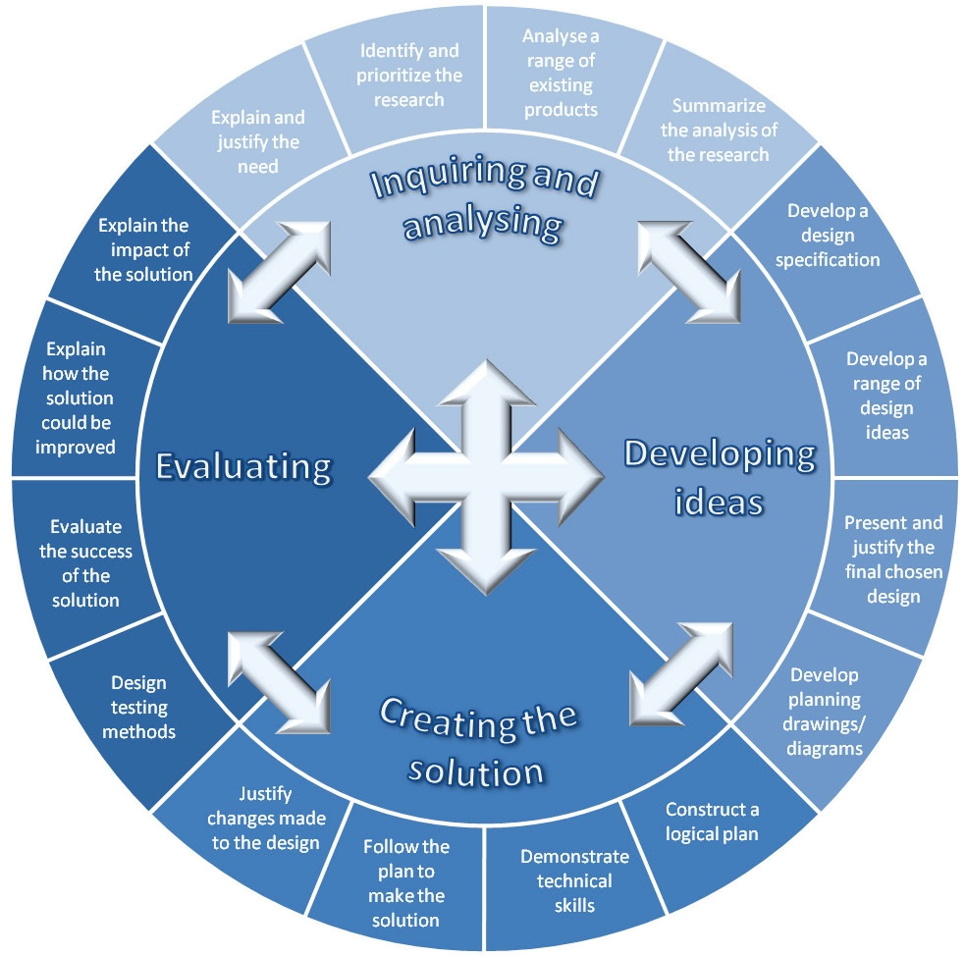

Name: _____________________________________________Period: _____________________

Introduction

Explain the task expected from you along with ideas you have. Briefly state what you expect from this project and what you expect the outcome to be. If this is a group project, mention details about your group and what you expect from them.

………………………………………………………………………………………………………………………………………………………………………………………………………………………………………………………………………………………………………………………………………………………………………………………………………………………………………………………………

………………………………………………………………………………………………………………………………………………………………………………………………………………………………………………………………………………………………………………………………………………………………………………………………………………………………………………………………
How is this task relevant to real issues?

………………………………………………………………………………………………………………………………………………………………………………………………………………………………………………………………………………………………………………………………………………………………………………………………………………………………………………………………
………………………………………………………………………………………………………………………………………………………………………………………………………………………………………………………………………………………………………………………………………………………………………………………………………………………………………………………………

How is the task related to the Global Context?
………………………………………………………………………………………………………………………………………………………………………………………………………………………………………………………………………………………………………………………………………………………………………………………………………………………………………………………………
A) Inquiring and analyzing: Research the task and how you might come up with a solution.
□ State the task in your own words, and why it is important to you and to others:
………………………………………………………………………………………………………………………………………………………………………………………………………………………………………………………………………………………………………………………………………………………………………………………………………………………………………………………………

□ Investigate and list available tools and resources and list them here:
………………………………………………………………………………………………………………………………………………………………………………………………………………………………………………………………………………………………………………………………………………………………………………………………………………………………………………………………

□ Write a concise description of the task and your solution (design brief) addressing who, what, why, and how:
………………………………………………………………………………………………………………………………………………………………………………………………………………………………………………………………………………………………………………………………………………………
□ Make a list of specifications that your product and presentation MUST have (design specification):
1.………………………………………………………………………………………………………………
2.………………………………………………………………………………………………………………
3.………………………………………………………………………………………………………………
4.………………………………………………………………………………………………………………
5. .……………………………………………………………………………………………………………..

□ List 4 different sources, and cite them properly.
1.………………………………………………………………………………………………………………
2.………………………………………………………………………………………………………………
3.………………………………………………………………………………………………………………
4.………………………………………………………………………………………………………………
□ Summarize how useful and reliable each source was:
.………………………………………………………………………………………………………………
………………………………………………………………………………………………………………
………………………………………………………………………………………………………………
………………………………………………………………………………………………………………

B) Developing Ideas: Present different designs, choose one, and tell why you choose it.
□ List and describe, in detail, 2 different designs for solution/product (drawings encouraged):
Design 1 | Design 2
Design Specification | Design 1 | Design 2
1.

2.

3.

4.

5.

□ Compare each design in detail to the design specification you made in section (A) – indicate “yes” or “no” to show whether the design fulfills that specification:

□ List your chosen design, and summarize why you chose it:
.……………………………………………………………………………………………………………

.……………………………………………………………………………………………………………

.……………………………………………………………………………………………………………

□ Discuss in detail what you will do each day until the project is finished (only for the create section). List what resources you will use on each day, and how much time you will spend working on the different pieces:
Day 1: Date: ___________ Double or single Period?______________________
WHAT I WILL DO: ………………………………………………………………………………………………………………………………………………………………………………………………………………………… RESOURCES I WILL NEED/USE: ……………………………………………………………………………………………………………
Day 2: Date: ___________ Double or single Period?______________________
WHAT I WILL DO: ………………………………………………………………………………………………………………………………………………………………………………………………………………………… RESOURCES I WILL NEED/USE: ……………………………………………………………………………………………………………
Day 3: Date: ___________ Double or single Period?______________________
WHAT I WILL DO: ………………………………………………………………………………………………………………………………………………………………………………………………………………………… RESOURCES I WILL NEED/USE: ……………………………………………………………………………………………………………
Day 4: Date: ___________ Double or single Period?______________________
WHAT I WILL DO: ………………………………………………………………………………………………………………………………………………………………………………………………………………………… RESOURCES I WILL NEED/USE: ……………………………………………………………………………………………………………
Day 5: Date: ___________ Double or single Period?______________________
WHAT I WILL DO: ………………………………………………………………………………………………………………………………………………………………………………………………………………………… RESOURCES I WILL NEED/USE: ……………………………………………………………………………………………………………

Day 6: Date: ___________ Double or single Period?______________________
WHAT I WILL DO: ………………………………………………………………………………………………………………………………………………………………………………………………………………………… RESOURCES I WILL NEED/USE: ……………………………………………………………………………………………………………
Day 7: Date: ___________ Double or single Period?______________________
WHAT I WILL DO: ………………………………………………………………………………………………………………………………………………………………………………………………………………………… RESOURCES I WILL NEED/USE: ……………………………………………………………………………………………………………
Day 8: Date: ___________ Double or single Period?______________________
WHAT I WILL DO: ………………………………………………………………………………………………………………………………………………………………………………………………………………………… RESOURCES I WILL NEED/USE: ……………………………………………………………………………………………………………
C) Creating the Solution: Write the process on how you created your product/solution.

□  What did you do first (mention your inquiring and analyzing):
……………………………………………………………………………………………………………………………………………………………………………………………………………………………………………………………………………………………………………………………………………………………………………………………………………………………………………………

□ What did you do second (mention the developing ideas design aspects):
………………………………………………………………………………………………………………………………………………………………………………………………………………………………………………………………………………………………………………………………………

□ What did you do third (mention the developing ideas planning aspects):
………………………………………………………………………………………………………………………………………………………………………………………………………………………………………………………………………………………………………………………………………
D) Evaluating: Reflect on the project.
□ Discuss your performance at each stage A-C of the process:
A. Inquiring and analyzing: …………………………………………………………………………………………………………………………………………………………………………………………………………………………
B. Developing ideas: …………………………………………………………………………………………………………………………………………………………………………………………………………………………
C. Creating the solution: …………………………………………………………………………………………………………………………………………………………………………………………………………………………

□ Talk about what you did well, whether you followed your plan, and what you could have done better:
……………………………………………………………………………………………………………………………………………………………………………………………………………………………………………………………………………………………………………………………………………………………………………………………………………………………………………………

□ Mention what you would do differently if you could do the whole thing over again:
……………………………………………………………………………………………………………………………………………………………………………………………………………………………………………………………………………………………………………………………………………………………………………………………………………………………………………………

□  Rate the final product against the design specification you made in section (A); was it successful?
……………………………………………………………………………………………………………………………………………………………………………………………………………………………………………………………………………………………………………………………………………………………………………………………………………………………………………………
□ Discuss the impact of your solution on you and/or others in the perspective of the MYP Global Context:
.……………………………………………………………………………………………………………………………………………………………………………………………………………………………………………………………………………………………………………………………………………………………………………………………………………………………………………………
THE DESIGN PROCESS

