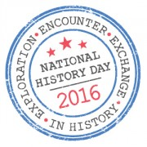
Name________________________________

National History Day
Exploration, Encounter, Exchange in History
Fact Store Sheet

Facts discovered while researching | How does your research support the theme? | Potential category for research (i.e. background, conclusion, statistics/data, causes, effects, thesis, long term consequences, etc...)

